Subject: Join Us For a Screening of the Documentary Angst
Dear (Student Body/Community),

Join us for a...

Screening of the Documentary
Angst, Raising Awareness around Anxiety

Day, Date at XX:XX AM/PM
at (Registration Link)
Film plus discussion will last 1 hour, 40 minutes

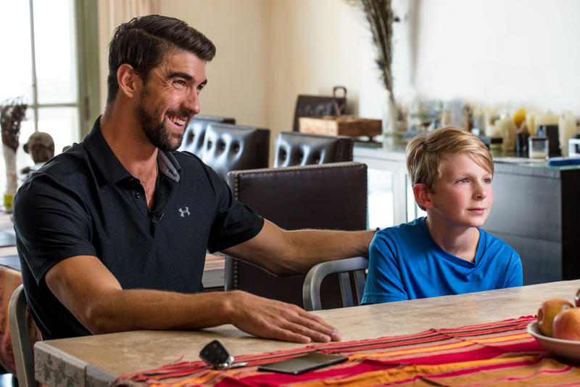

On top of academic and social stress, the uncertainty and fears of this past pandemic year have brought all of us a lot more anxiety than before. Angst helps break this down, explaining what’s going on, and what we can do about it to help both ourselves and others. It features World Champion Swimmer Michael Phelps, experts in the field, and regular teenagers

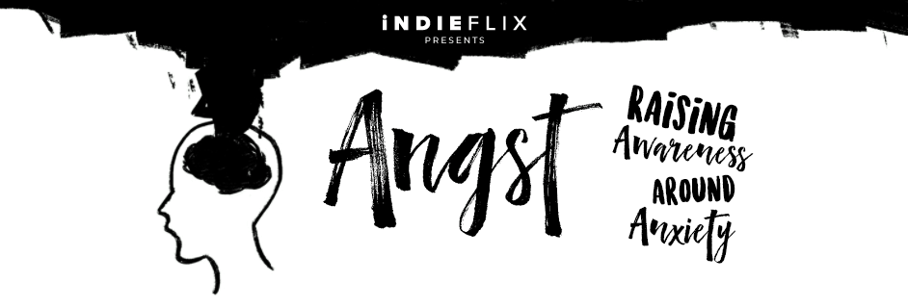

Includes a post-film panel discussion and Q&A.

Register to join us here: (registration link)

Looking forward to seeing you there!

"I never knew that what I was experiencing was severe anxiety. I'm so grateful to know that there is treatment." 18 year old college student - Seattle, WA

