Subject: LIKE Survey
Dear (Student Body/Community),

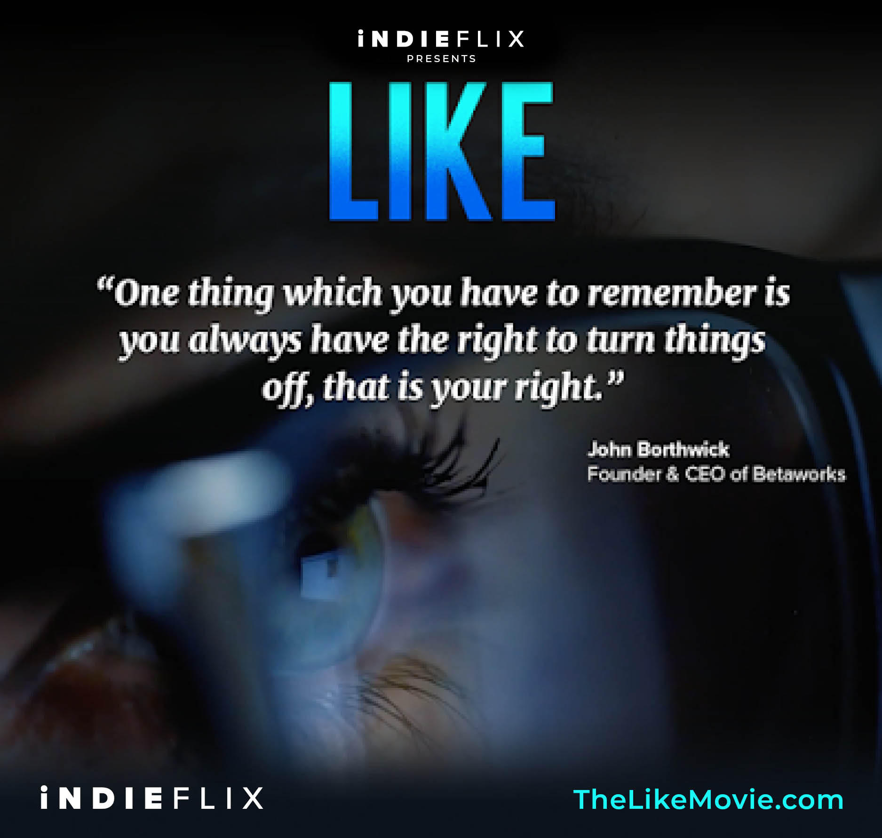

We hope that you found ‘LIKE’ interesting and helpful.

Please complete the post-screening survey here. It should take about 5 minutes to complete.
(insert your screening survey link)

To learn more, and access some of the resources that came with the screening, click here.

We’d love to hear from you! If anything came up that you’d like to discuss as a result of watching LIKE, do get in touch with ……… at (insert email address).

We wish you all a balanced, happy and healthy week,

